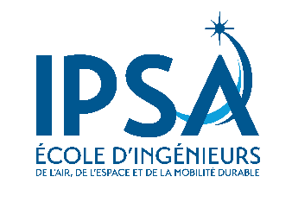

APPLICATION FORM
SUMMER SCHOOL 2023: IMAGINE – DEVELOP - FLY

If filled by hand, this form should be completed in black and capital letters.
STUDENT PERSONAL DATA (to be completed by the applying student)
Family name
First name(s)
Gender | ☐ Female ☐ Male
Date of birth (DD/MM/YYYY)
Place of Birth
Nationality
Address
Phone number (with area code)
E-mail address
Current degree followed
Number of higher education study years
Disability | ☐ Yes ☐ No
If yes, please indicate your disability
LANGUAGE COMPETENCES
Mother tongue:
Other languages | (Estimated) Level | You are currently studying this language |  | You have sufficient knowledge to follow lectures
 |  | Yes | No | Yes | No
English
French
Other:

PREVIOUS HIGHER EDUCATION
Year | University | Field of Study | Diploma / Degree Obtained

BRIEFLY STATE THE REASONS WHY YOU WISH TO FOLLOW THIS SUMMER PROGRAM

STUDENT’S DECLARATION
I hereby declare that the information provided above is accurate and that, if accepted, I will abide by IPSA rules and regulations.
Student’ signature: | Date:  ……………….……../…………………………/…………………………..

This form must be submitted to
international@ipsa.fr

Deadline application: May 15, 2023

Your application must be accompanied by the following documents:
- Previous and current transcript of records from your home university (in English);
- Photocopy of a valid passport or ID (if European);
- Proof of English proficiency (B2 level);
- A proof of payment of €60 for application expenses*, by bank transfer.
These charges will not be refunded under any circumstances, even if your
application is unsuccessful.
IPSA BANK DATA

Bank: Société Générale
Account holder: INSTITUT POLYTECHNIQUE DES SCIENCES
Swift code (or BIC Code): SOGEFRPP
IBAN: FR76 3000 3043 8200 0200 1210 477
Reference: Summer School 2022 / Student name
*Students from our partner universities are exempted from the €60
application fee.

